**EE4266 Assignment 1**

**Zhang Zeyu**

**U1620474K**

Handphone model: Huawei HONOR 9X

**Part one: Determining the focal lengths**

A photo was taken to determine the focal lengths of the handphone camera. The focal point was adjusted to the furthest point in the picture possible to avoid unnecessary change in focal lengths. The image has a dimension of 3000 x 4000 Pixels (12.00 MPixels) (3:4) (specifications obtained by using IrfanView 64).



Figure 1

By using IrfanView 64 to inspect, the corresponding number of pixels of the height is obtained to be 777 whereas the corresponding number of pixels of the width is obtained to be 178:

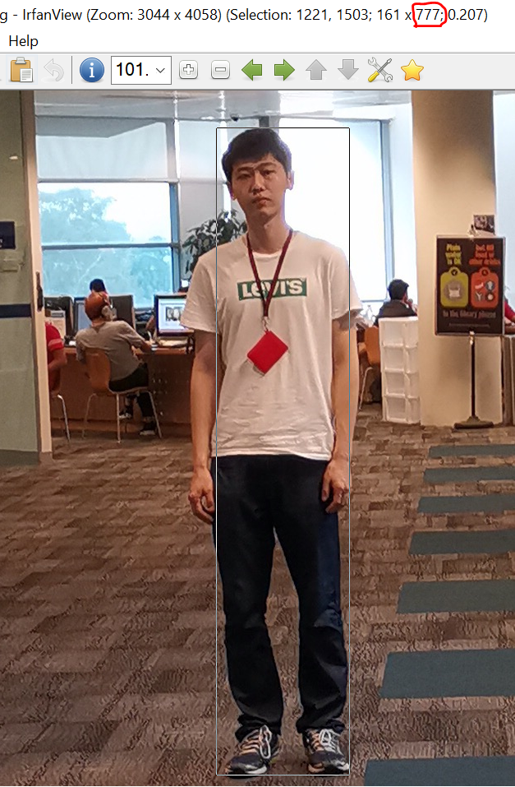

Figure 2

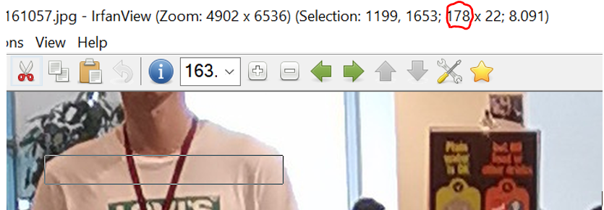

Figure 3

The following figure illustrates the rationale of calculating the focal lengths. D is the distance between the person in the image whereas f is the focal length. L is the dimension (either height or width) of the person whereas l is the number of pixels displayed in the image which correspond to the dimension (height or width) of the person. The measurened data are:

1. The height of the person is approximately 1.85 m;
2. The width of the person is approximately 0.41 m (at the shoulder region);
3. The distance of the person from the handphone camera is approximately 7.0 m. It was measured by first measuring the length of a carpet tile unit and then counting the total number of such unit in between the phone camera and the person. One carpet tile unit is 0.5m by 0.5m and there are exactly 14 such units in between the phone camera and the person.

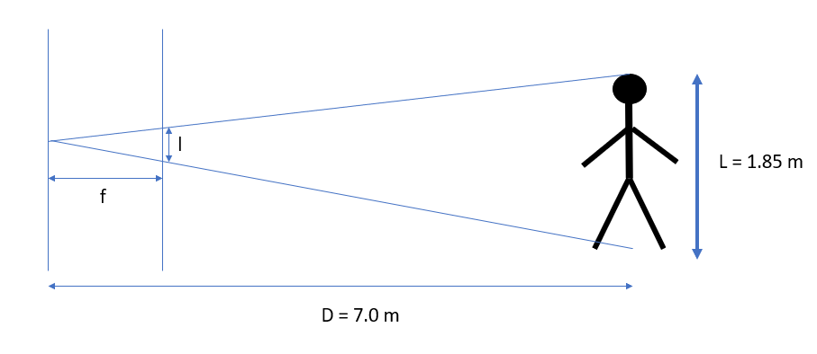

Figure 4

From the Figure 4 illustrated above, we can establish the following relation according to the similar triangle rules:

Substitute the values of l, D and L into the equation, we obtain that

Where is the vertical focal length.

Now change L to width and redo the computation, we obtain that

Where is the horizontal focal length.

It can be observed that the vertical and the horizontal focal lengths are quite similar.

**Part two: The Field of View (FoV)**

Calculating the FoV of the handphone camera can be viewed as a variation of the first problem, in which the focal lengths are known and the l is the image’s dimension which is stated before.

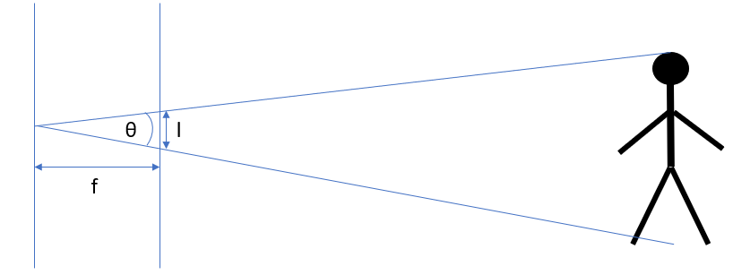

Figure 5

According to basic trigonometry, FoV .

Horizontal FoV

Vertical FoV

**Part three: Depth of the person in each image**

The following three photos are taken with the same person standing at 3 meters, 5 meters and 10 meters away from the handphone camera respectively. The way to calculate the distance is exactly the same as in part one.



Figure 6 3 meters away Figure 7 5 meters away



Figure 8 10 meters away

To calculate the depth of each person, we can use the same formula used in calculating the focal lengths in part one, except that now the unknown parameter is D:

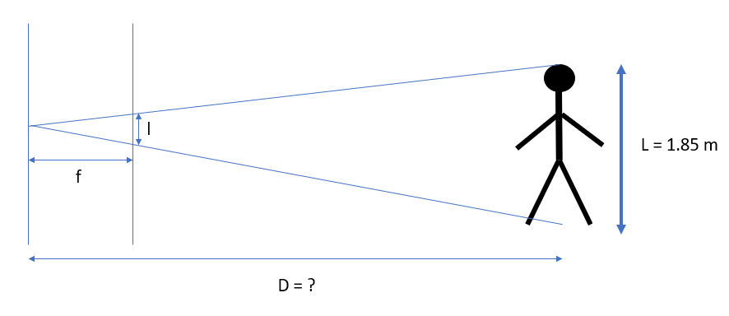

Figure 9

For all intents and purposes, we take f as the vertical focal length and use the corresponding parameters and we still use IrfanView 64 to obtain the pixels of the height of the person in the images.

3 meters:

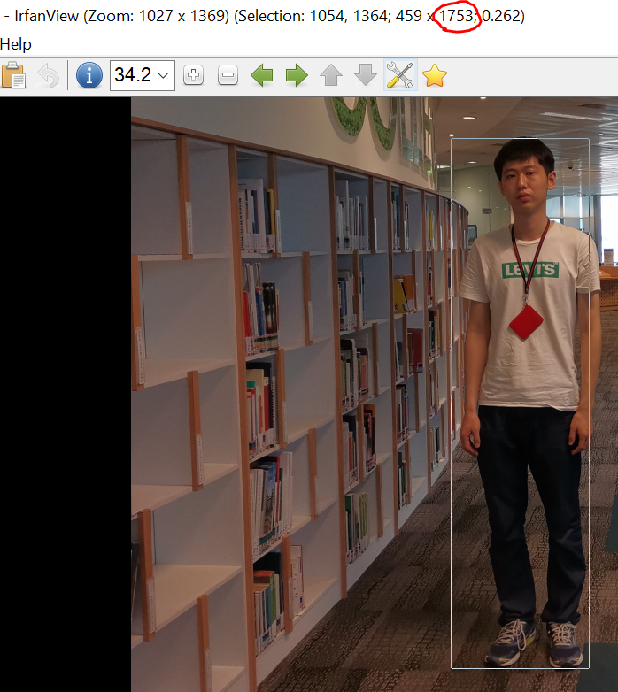

Figure 10

5 meters:

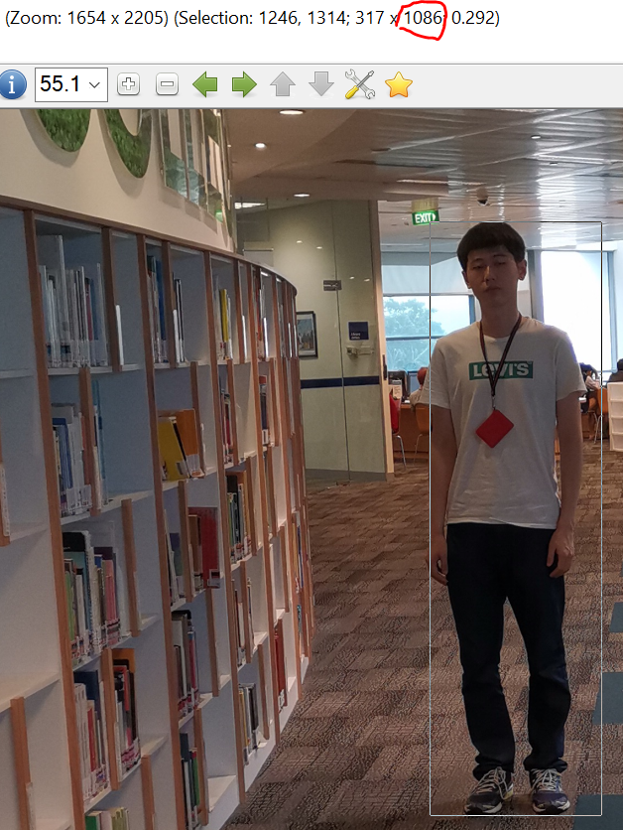

Figure 11

10 meters:

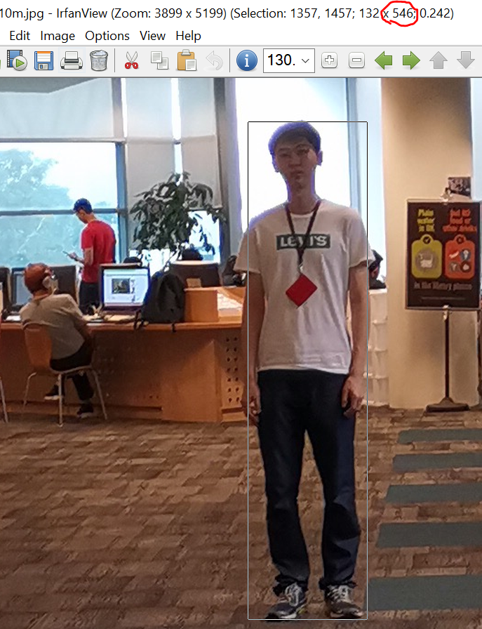

Figure 12

Observations:

The calculated depths (distances) is very close to the actual measured distances. Nevertheless, minor discrepancies that arose might be due to the following factors:

1. All the parameters used the calculations are approximated to certain degree of accuracies;
2. The person is not standing entirely uprightly which might cause further discrepancy in height approximation;
3. When using IrfanView 64 to measure the pixels information, the cropping is done by treating the content as 2-dimensional objects, but in fact the image is a projection of the 3-dimensional objects. As a result, the front and the back of the feet of the person have a perceived ‘height difference’ as can be observed from all the photos, but as a rule of thumb we took the bottom in the image (the front of feet) as the lower bound of the bounding box. This 3D-to-2D translation can also cause discrepancies.